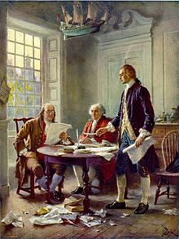
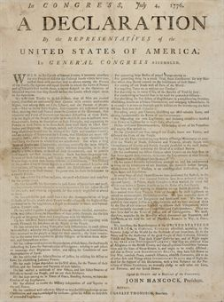

FOUNDATIONS
The Teenagers’ Declaration of Independence

Task
The United States government feels that your age group is lacking some rights and responsibilities and wants your help in declaring independence for all teenagers. You will now be given the chance to obtain privileges that you have always wanted as you create your own Teenagers’ Declaration of Independence. While you are declaring your need for freedom, keep in mind that you must have reasons that you deserve the rights you wish to obtain. Also, you have to be prepared to compromise by accepting responsibilities that will help you earn privileges.

Although this may be hard to believe, you are not the only teenager out there wishing for more rights and privileges. (You’re shocked, I know). So, you will work to not only create a Teenagers’ Declaration of Independence, but also to present your ideas to be judged by your peers. Your Declarations will be posted on a blog for all high school students to read and consider. All will vote, choosing the Declaration that best fits everyone involved by “liking” their favorite Declaration. Remember that you are acting as a representative for all American teenagers and plan accordingly.

Requirements
- You must write your Declaration following the format of the original Declaration of Independence, using at least five of the rhetorical devices applied. Revisit your notes if you’re reading this and have no idea what I’m talking about.

- Include at least ten rights or privileges that are appropriate for school. But, Mrs. Schultz, it’s funny to be inappropriate in school! You may think you’re funny, but I do not. And when you turn in a project with inappropriate language, innuendoes, and etc., you get a zero, which I don’t think you’ll find funny. Neither will your parents, who of course will be contacted. Moral of this story: be appropriate.
An example of a right and/or privilege you might like is to start school one hour later.

- Include, to match your requested rights, at least ten new responsibilities that will help you earn your new privileges. Your responsibilities must connect with your privileges.
For example, if you want to start school one hour later, you may agree to stay one hour later as well. You don’t need to follow this exact model, but you can’t place a privilege with a completely unrelated responsibility or with something that looks like a responsibility but is really just another privilege. Don’t ask for school to start an hour later and then say that you are willing to give up homework for that right.

- You must introduce the idea of independence for teenagers in an introductory paragraph that hooks your readers and prompts them to read on. Your aim is to get readers to buy in to the idea that you are in need of more personal freedoms as a teen. With this in mind, write an interesting, concise introduction.

- End your Declaration with a brief look at a future with more rights for teens in a concluding paragraph. Remind your readers of all of the positive outcomes that will result from awarding teens more privileges. Don’t forget to address your new responsibilities and how they will factor in to improved interactions between teens and American society.

Resources
When brainstorming, composing your declaration, and creating your presentation, these resources are valuable for providing information you might need when you get stuck. Use what you will. Keep track of which sources you consult, as you will need to cite them on a works cited or works consulted page written in precise MLA format. We will go over some basic formatting for websites, but the final resource on this list, the Online Writing Lab at Purdue, is an excellent tool to use when citing sources.
- http://www.ushistory.org/declaration/index.htm
- http://www.archives.gov/exhibits/charters/charters.html
- http://www.loc.gov/exhibits/declara/declara1.html
- http://holidays.kaboose.com/july4-decl.html
- http://congressforkids.net/Independence_declaration_1.htm
- www.refdesk.com
- www.americanrhetoric.com
- http://owl.english.purdue.edu/owl/resource/557/01/

Requirements
- 12-point, Times New Roman font
- Block formatting
- Your name in the upper left corner

Turn it in Instructions
Email your Word document as an attachment to schultzt@springvalley.k12.wi.us from your SV school gmail account.

Your name will be removed from the document by me and given a number. Then it will be posted for viewing by the rest of the school, who will vote on the best representation of teenagers’ needs.

