UNIT 1: ORIGINS
Story Time: A Research Assignment
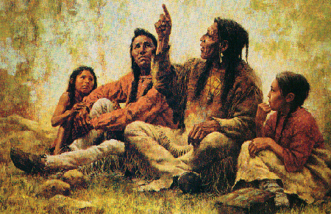
http://bentonseculit.blogspot.com/

Before Europeans colonized this country, it was inhabited with a vast amount of Native peoples, all with their own specific rules and customs. Today, the Native American culture has been all but wiped out from much of our country, with very few still practicing the unique traditions of their nations.

After reading some stories of creation from various Native American nations, you have a very limited introduction to the tradition of storytelling in the Native American culture. This project requires you to explore this topic further by reading Native American legends, researching a brief background of the nation from which the stories came, and writing a coherent report that contains your findings.

In class, you will visit http://www.firstpeople.us/ and spend some time exploring the immense variety of legends from Native American nations across the country. Please read more than one legend before choosing which to share with your peers. Also, keep in mind that some of the legends have humorous endings that may be more suited to an adult audience. While funny, yes, do choose your legend wisely—failure to choose appropriate-for-school stories will result in a ZERO for the project.

The format of your informative writing project should be as follows:
- Introduce the name, location, and significant information about the Native American nation you’ve chosen.
- Provide a summary of the myth you’ve chosen.
- Explain the purpose of the myth. Is it meant to teach a lesson, explain origin of natural phenomena, teach the creation of the world…?
- Explain how your myth supports the reoccurring ideas and common themes of Native American storytelling (refer to III in your notes).
- Explain why your myth reinforces the power that language has on people and culture. Discuss the details that make your myth effective and valuable. What makes it a memorable story? Why is the theme, moral, or message an important one to know?
- Repeat steps 2-5 for another myth from the same nation. Make an attempt to find two myths that were told for different reasons. If you can, find one creation and one origin myth. If not, find two stories with clear differences in purpose and/or two stories that support the common themes of Native American storytelling in different ways.

Requirements of your informative writing project are as follows:
- Use 12-point, Times New Roman font and double spacing.
- Include a heading: (1) Your name (2) Class and Hour (3) Mrs. Schultz (4) Date
- Use at least two direct quotations from the sources you consult for research and cite each correctly.
- You must use at least one print source. You have to use an actual book… oh, no!
- Include a “Works Cited” page using MLA formatting.

